14. Perform Perspective Transformation on an Image Using Python and OpenCV
Aim
To perform perspective transformation on an image using Python and OpenCV.
Procedure
- Import OpenCV and NumPy libraries.
- Read the input image.
- Select four points from the original image.
- Define four corresponding points for the output image.
- Apply perspective transformation using cv2.getPerspectiveTransform() and cv2.warpPerspective().
- Display the original and transformed images.
Program

import cv2
import numpy as np

img = cv2.imread("sample.jpg")

rows, cols = img.shape[:2]

pts1 = np.float32([[50, 50], [cols-50, 50], [50, rows-50], [cols-50, rows-50]])
pts2 = np.float32([[0, 0], [cols, 0], [50, rows], [cols-50, rows]])

matrix = cv2.getPerspectiveTransform(pts1, pts2)
result = cv2.warpPerspective(img, matrix, (cols, rows))

cv2.imshow("Original Image", img)
cv2.imshow("Perspective Transformation", result)

cv2.waitKey(0)
cv2.destroyAllWindows()
Input
An image named sample.jpg stored in the same folder as the Python program.
Output
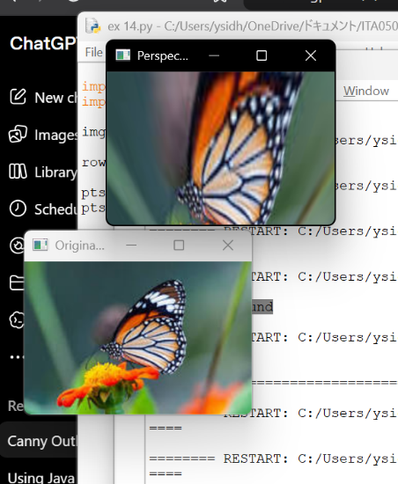
- Original image
- Perspective-transformed image
Result
Thus, perspective transformation was successfully performed on the given image using Python and OpenCV.

